|  |  |  |
| --- | --- | --- |
| **T.Y.BSC(I.T) SEM-VI Maharashtra College Advanced Mobile Programming** | |  |
|  | **Practical :-9 B**  **Question**  **Create the media API in android to play a video file.** |  |
| **Activity_main.xml**  **Drag and drop VideoView and Button from Palette**  *<?***xml version="1.0" encoding="utf-8"***?>*  <**RelativeLayout xmlns:android="**[**http://schemas.android.com/apk/res/android**](http://schemas.android.com/apk/res/android)**" xmlns:app="**[**http://schemas.android.com/apk/res-auto"**](http://schemas.android.com/apk/res-auto) **xmlns:tools="**[**http://schemas.android.com/tools**](http://schemas.android.com/tools)**" android:layout_width="match_parent" android:layout_height="match_parent"**  **tools:context=".MainActivity"**>  <**VideoView android:id="@+id/videoView" android:layout_width="wrap_content"**  **android:layout_height="wrap_content"** />  <**Button android:id="@+id/btnPlay"**  **android:layout_width="wrap_content" android:layout_height="wrap_content" android:layout_alignParentEnd="true" android:layout_alignParentRight="true" android:layout_alignParentBottom="true" android:layout_marginEnd="151dp" android:layout_marginRight="151dp" android:layout_marginBottom="274dp" android:onClick="playVideo" android:text="Play Video"** />  </**RelativeLayout**> |  |
| **Main_Activity.java**  **package** com.maharashtracollege.ansri avez 306;  **import** androidx.appcompat.app.AppCompatActivity;  **import** android.media.MediaPlayer;  **import** android.net.Uri;  **import** android.os.Bundle;  **import** android.os.Environment; |  |
|  | |  |

**import** android.util.Log; **import** android.view.View; **import** android.widget.Button;

**import** android.widget.ImageButton; **import** android.widget.MediaController; **import** android.widget.Toast;

**import** android.widget.VideoView;

**public class** MainActivity **extends** AppCompatActivity { VideoView **videoview**;

Button **btn**;

@Override

**protected void** onCreate(Bundle savedInstanceState) { **super**.onCreate(savedInstanceState); setContentView(R.layout.***activity_main***);

}

**public void** playVideo(View view)

{

**videoview** = (VideoView) findViewById(R.id.***videoView***);

**try** {

MediaController mediacontroller = **new** MediaController( MainActivity.**this**);

mediacontroller.setAnchorView(**videoview**);

Uri uri = Uri.*parse*(**"android.resource://"** + getPackageName() + **"/"** + R.raw.***myvideo***);

**videoview**.setMediaController(mediacontroller); **videoview**.setVideoURI(uri);

} **catch** (Exception e) { Log.*e*(**"Error"**, e.getMessage()); e.printStackTrace();

}

**videoview**.requestFocus();

**videoview**.setOnPreparedListener(**new** MediaPlayer.OnPreparedListener() {

**public void** onPrepared(MediaPlayer mp) {

**videoview**.start();

}

});

}}

Note: For this practical we to copy the .mp4 file and create the folder raw in the res as follows

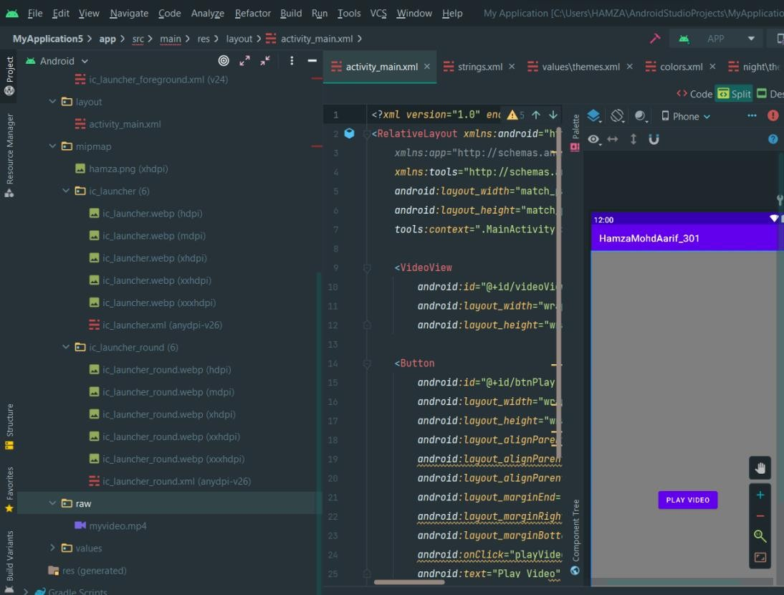

myvideo.mp4 is used for video playing

